|  |
| --- |
|  |

Visit by Helene Hellmark-Knutsson, Minister for Higher Education and Research to Japan

October 3-7, 2015

Organized by

Growth Analysis Tokyo and

Embassy of Sweden Tokyo

Contact Information:

Niklas Z Kviselius: +81 80 4189 1276

Shiori Schules: +81 80 1111 3954

Contents

Itinerary 5

Saturday, October 3 5

12:30-15:15 EU-Japan Science Policy Forum 5

15:30-16:30 Meeting with Dr. Yuko Harayama at Council for Science, Technology and Innovation (CSTI) 6

Sunday, October 4 8

8:30-9:30 Breakfast with Swedish presidents of universities 8

10:00-11:00 Opening Plenary Session 8

11:10-12:00 Plenary Session 101: Energy and Environment 9

12:00-12:15 Bilateral meeting with Mr. Arkady Dvorkovich, Deputy Prime Minister of the Russian Federation 9

12:20-13:45 Exclusive Lunch Reception for Ministers 9

13:45-14:15 Bilateral Meeting with H.E.Mr. Hakubun Shimomura, MEXT 10

14:20-14:35 Bilateral Meeting with Dr. Mohammad Farhadi, Minister of Science, Research and Technology, Iran 10

14:45-15:15 Bilateral Meeting with Dr. John P. Holdren 11

15:25 Stand by at Room D 11

15:40-16:40 Plenary Session 103B: The Role of Universities 11

16:40-18:50 S&T Ministers’ Roundtable 12

16:20 Door Open 12

16:40 - 16:50 Opening Remarks by Minister of State for Science and Technology 12

Policy, Japan 12

16:50 - 17:10 Presentations for Discussion 12

17:10 - 18:35 Discussion 12

18:35 - 18:45 Closing Remarks 12

After the meeting Group Photo 12

18:50-21:00 Official Dinner 12

21:00 Transport to the hotel by shuttle bus provided by STS Forum 12

Monday, October 5 13

10:00-11:45 Guided Tour of Kyoto University 13

12:30-13:20 Lunch at ICC 13

13:20-14:30 Plenary Session 202: Global Health 13

14:30-15:00 Bilateral Meeting with Professor Jean-Pierre Bourguignon, President, European Research Council (ERC), European Commission 14

15:00-16:20 STS Seminar “Responsible Public Dialog in Science and Technology” 14

16:20-16:50 Coffee Break 14

16:50-17:05 Coffee with Elsevier, Inc. 14

17:15-17:45 Bilateral meeting with the president of Japan Science & Technology Agency (JST) 15

18:30-20:30 Dinner arranged by STS Forum 16

Tuesday, October 6 17

12:00-13:00 Lunch 17

14:45-15:45 Meeting with the president of the Japan Agency for Medical Research and Development (AMED) 17

18:30-20:30 Dinner hosted by Ambassador Magnus Robach 18

Wednesday, October 7 21

Appendices: References 22

Appendix A: Meeting with Niklas! 22

Appendix B: Kyoto City Map & the hotel 24

Appendix C: Japanese restaurant “Suiren” 25

Appendix D: Kyoto University 26

Appendix E: Washoku EN Marunouchi 27

Appendix F: AMED (Japan Agency for Medical Research and Development) 28

Appendix G: Contact information 29

**Delegation to Japan**

H.E.Ms. Helene Hellmark Knutsson, Minister for Higher Education and Research

Ms. Marija Milivojevic, Head of Section, Division for Research Policy

Mr. Klas-Herman Lundgren, Political Advisor to the Minister

Ms. Maria Soläng, Press Secretary to the Minister

Accompanying from Growth Analysis Tokyo office

Dr. Niklas Kviselius, Science and Innovation Counsellor and Head of Office of Science and Innovation, Embassy of Sweden

Itinerary

## Saturday, October 3

8:55 Arrival at Kansai International Airport by Finnair (AY77)

Meet with Niklas Kviselius at the terminal 1 – See Appendix A

Take the airport express Haruka to Kyoto Station

Kansai Airport 10:16 – Kyoto Station 11:31

Hotel Granvia Kyoto is right next to the Kyoto station (leave the luggage)

11:50 Meet at Hotel Granvia Kyoto lobby and transport to Kyoto International Conference Center (ICC) by taxi (30 min) – See Appendix B

Pick up by Niklas Kviselius

### 12:30-15:15 EU-Japan Science Policy Forum

*Venue: Room D at ICC*

Inquiry: Leonidas Karapiperis: 03-5422-6050

Tom Kuczynski: 03-5422-6058

*\*Seated lunch will be served in the course of the event.*

***Main Topic:***

* “Foresight for STI policy in an era of accelerated change”

***Agenda***

***Masters of Ceremony:***

**Leonidas KARAPIPERIS,** Minister-Counsellor, Head of S&T,Delegation of the European Union to Japan

**Tateo ARIMOTO,** Professor, National Graduate Institute for Policy Studies (GRIPS)

12:30 - 12:45 Welcome

Viorel ISTICIOAIA-BUDURA, Ambassador of the European

Union to Japan

Takahiro UEYAMA, Vice President, GRIPS

Koji OMI Chair and Founder of the STS Forum

12:45 - 12:55 Toast

Michinari HAMAGUCHI, President, Japan Science and

Technology Agency

12:55 - 13:20 Policy briefs

Paul RÜBIG, Chair, Science and Technology Options Assessment

(STOA) Panel, European Parliament (EP)

Yuko HARAYAMA, Executive Member, Council of Science,

Technology and Innovation (CSTI), Cabinet Office (CAO)

Xavier TROUSSARD, Head of Foresight & Behavioural Insights,

Joint Research Centre (JRC), European Commission (EC)

13:20 - 14:00 Introductory remarks on foresight practices in Europe and Japan

Naoki SAITO, [Japan] Deputy Director-General, National Institute

of Science and Technology Policy (NISTEP), Ministry of Education,

Culture, Sports, Science and Technology (MEXT)

Mark WALPORT, [UK] Chief Advisor to the UK Government

Tomoji KAWAI, [Japan] Executive Director, Technology Strategy

Center, New Energy and Industrial Technology Development

Organization (NEDO)

Pascal COLOMBANI, [France] Vice-Chairman of the Strategic

Council for Research and Chairman of the Board of Directors of

Valeo

Takao KURAMOCHI, [Japan] Senior Deputy Director-General,

Center for Research and Development Strategy, Japan Science and

Technology Agency

Matthias KLEINER, [Germany] President, Leibniz Association

Satoru OHTAKE, [Japan] Senior Executive Director, Japan Science

and Technology Agency (JST)

14:00 - 15:15 Discussion

Moderators:

Atsushi SUNAMI, Executive Advisor to the President, GRIPS

Reijo Munther, Director, Enterprise and Innovation Department,

Ministry of Employment of Finalnd

15:15 - 15:30 Closing remarks

Paul RÜBIG, Chair, STOA Panel, EP Yuko HARAYAMA

Executive Member, CSTI, CAO

### http://2.bp.blogspot.com/-sZ0ugJLWkI0/Ur1GPaI4j_I/AAAAAAAAcaE/t08ufIizPm8/s800/present_box.png15:30-16:15 Meeting with Dr. Yuko Harayama at Council for Science, Technology and Innovation (CSTI)

*Venue: Room 562 at ICC*

***Participants:***

* Dr. Yuko Harayama, Executive Member, Council for Science, Technology and Innovation (CSTI), Cabinet Office
* Mr. Manago Hiroshi, Principal Deputy Director for International Affairs, Bureau of Science, Technology and Innovation, Cabinet Office, Gov. of Japan
* Ms. Kihoko Suda, Deputy Director for International Affairs, Bureau of Science, Technology and Innovation, Cabinet Office, Gov. of Japan
* Dr. Naoya Fukuda, Senior S&T Policy Fellow for International Affairs, Bureau of Science, Technology and Innovation, Cabinet Office, Gov. of Japan

|  |
| --- |
| **Background Information** |
| organization chartThe Council for Science and Technology and Innovation (CSTI), former Council for Science and Technology Policy (CSTP) was established in January 2001 within the Cabinet Office as one of the four governmental councils of important policies of Cabinet Office. The Council acts as a "source of wisdom" that assists the Prime Minister and the Cabinet and oversees science and technology policies in Japan as well as plan and coordinate comprehensive and basic policies on science and technology from a vantage point higher than that of the various ministries. [*http://www8.cao.go.jp/cstp/english/*](http://www8.cao.go.jp/cstp/english/)  Dr. Yuko Harayama rejoined the CSTI as an Executive Member in 2013. She is the former Deputy Director of the Directorate for Science, Technology and Industry, OECD. She is a Legion D’Honneur recipient (Chevalier), recognized by the President of France for her research on science and technology policy. Previously, she was Professor in the Management Science and Technology Department at the Graduate School of Engineering of Tohoku University.  Dr. Harayama holds a Ph.D. in education sciences and a Ph.D. in economics, both from the University of Geneva. Prior to joining Tohoku University, she was a Fellow at the Research Institute of Economy, Trade and Industry in Japan and an Assistant Professor in the Department of Political Economy at the University of Geneva. |

16:30 Walk to Grand Prince Hotel to pick up ID passes

16:45 Transport to Hotel Granvia Kyoto by taxi (30 min) and check in (Obtain the shuttle bus schedule at the front desk)

17:45 Transport by taxi to head to “Suiren” the Kyoto cuisine restaurant in the Kyoto City (10 min) – See Appendix C

18:00 Country briefing and going through the program by Niklas Kviselius



Suiren - the cozy restaurant on Miyagawasuji Street, one of the Geisha districts, welcomes anyone with its casual and relaxing atmosphere. While retaining the conventional cooking styles of Kyoto cuisine, Shimatani, the chef, tries out new cooking techniques and ingredients based on his experience.  His cheerful character is also an important “spice” for his dishes which attract regular customers from afar.

Tel: 075-748-1988

*Reserved under “Niklas”

*Payable by credit card

20:00 Transport by taxi to Hotel Granvia Kyoto (10 min)

## Sunday, October 4

8:00 Meet at Hotel Granvia Kyoto lobby and transport to Grand Prince Hotel Kyoto by taxi (30 min)

Pick up by Niklas Kviselius

### 8:30-9:30 Breakfast with Swedish researchers

*Venue: Room “Kurama”at Grand Prince Hotel Kyoto*

***Participants (as of October 2nd):***

* Dr. Lena Gustafsson, Vice Chancellor, Umeå University
* Dr. Astrid Söderbergh Widding, Vice Chancellor, Stockholm University
* Dr. Helene Dannetun, Vice Chancellor, Linköping University
* Dr. Stefan Bengtsson, President and CEO, Chalmers University of Technology
* Dr. Anders Malmberg, Deputy Vice Chancellor, Uppsala University
* Dr. Eva Wiberg, Deputy Vice Chancellor, Lund University
* Mr. Henrik Hofvendahl – Accompanying VC of Lund University
* Dr. Viktor Öwall, Dean, Faculty of Engineering, Lund University
* Dr. Anders Hamsten, Vice Chancellor, Karolinska Institutet
* Ms. Ulrika Widegren, Scientific Coordinator, Karolinska Institutet
* Dr. Harriet Wallberg, University Chancellor, Swedish Higher Education Authority (SHEA)
* Dr. Andreas Göthenberg, Executive Director, The Swedish Foundation for International Cooperation in Research and Higher Education (STINT)
* Dr. Karl Börjesson, Assistant Professor, Department of Chemistry and Molecular Biology, University of Gothenburg
* Dr. Lars Hultman, CEO, Swedish Foundation for Strategic Research
* Dr. Magnus Jonsson, Assistant Professor, Organic Electronics, Linköping University
* Dr. Anders Karlsson, Vice President, Global Academic Relations Asia-Pacific, Elsevier
* Dr. Jari Kinaret, Head of Condensed Matter Theory Division, Chalmers University of Technology
* Dr. Ingela Lanekoff, Assistant Professor, Department of Chemistry, Uppsala University
* Dr. Edmund Loh, Ass. Prof., Karolinska Institutet
* Mr. Stefan Noreén, Advisor, RIKEN
* Mr. Olof Sandén, CEO, RISE, Research Institutes of Sweden
* Dr. Lennart Stenberg, Senior Advisor, Operational Development Division, VINNOVA
* Dr. Anders Clausen, University of Gothenburg
* Dr. Anna Hanner, CHE – Fibre and Polymer Technology, KTH
* Dr. Eric Johnston, Researcher, Organic Chemistry, Stockholm University

9:30 Walk to Kyoto International Conference Center (ICC)

### 10:00-11:00 Opening Plenary Session

*Venue: Main Hall of ICC*

***Speakers:***

* Dr. Koji Omi, Founder and Chairman, STS Forum, JP
* Mr. Shinzo Abe, Prime Minister, Government of Japan, JP
* Mr. Manuel Valls, Prime Minister, Government of the French Republic, FR
* Mr. Ranil Wickremesinghe, Prime Minister, Government of Democratic Socialist Republic of Sri Lanka, LK
* Dr. Sadayuki Sakakibara, Chairman, Keidanren (Japan Business Federation); Chairman, Toray Industries, Inc., JP
* Mr. Arkady Dvorkovich, Deputy Prime Minister, Government of the Russian Federation, RU
* Dr. John P. Holdren, Director of Office of Science and Technology Policy (OSTP), Executive Office of the President (EOP) of the United States, US

### 11:10-12:00 Plenary Session 101: Energy and Environment

(Session till 12:20) *Venue: Main Hall of ICC*

***Speakers:***

* [Chair] Dr. Rush Holt, Jr., CEO, AAAS, US
* Mr. Takayuki Ueda, Vice-Minister for International Affairs, Ministry of Economy, Trade and Industry (METI), JP
* Dr. Gordon McBean, President of International Council for Science (ICSU), Co-Chair of Governing Council, Future Earth, Director of Research and External Relations – Centre for Environment and Sustainability, Institute for Catastrophic Loss Reduction, Department of Geography, Western Universtiy, CA
* Dr.-Ing. Matthias Kleiner, President, Leibniz Association, DE
* Mr. Alexander Shokhin, Russian Union of Industrialists and Entrepreneurs, RU
* Mr. Takeshi Uchiyamada, Chairman of the board, Toyota Motor Corporation, JP

### 12:00-12:15 Bilateral meeting with Mr. Arkady Dvorkovich, Deputy Prime Minister of the Russian Federation

*Venue: Coffee area at ICC*

Contact: Sergey ELISEEV, First Secretary, Embassy of Russia

Phone: 080-9409-4224

|  |
| --- |
| **Background Information** |
| **Mr. Arkady Dvorkovich, Deputy Prime Minister of the Russian Federation**  http://government.ru/media/persons/240x240/41d49c3421bb7e7c8a78.pngBorn in 1972. Mr. Dvorkovich has been appointed Deputy Prime Minister of the Russian Federation by Presidential Executive Order since 2012. Previous positions include Aide to the President of the Russian Federation, Head of the Presidential Experts' Directorate, Deputy Minister for Economic Development and Trade as well as Expert at the Centre for Strategic Research. He holds Masters Degrees in Economics from both the New Economic School, Moscow and Duke University, North Carolina. |

### 12:20-13:45 Exclusive Lunch Reception for Ministers

*Venue: Annex Room at ICC*

***Registered:***

* H.E.Ms. Helene Hellmark Knutsson, Minister of Higher Education and Research
* Ms. Marija Miliojevic, Head of Section, Ministry of Education and Research
* Mr. Klas-Herman Lundgren, Political Advisor to the Minister

*(Niklas and Maria are on their own for lunch.)*

|  |
| --- |
| **Background Information** |
| **Shunichi Yamaguchi, Minister of State for Science and Technology Policy**  yamaguchi S&T ministerBorn February 1950, Yamaguchi belongs to the LDP – Liberal Democratic Party – and is a member of the House of Representatives. When the second Abe Cabinet was inaugurated, Yamaguchi was appointed as Minister of State for Okinawa and Northern Territories Affairs, Minister of State for Consumer Affairs and Food Safety, Minister of State for Space Policy, Minister in charge of Information Technology Policy, Minister in charge of “Challenge Again” Initiative, and Minister in charge of “Cool Japan” Strategy at the same time as the Minister of State for Science and Technology. He also pursues for regional development. |

### http://2.bp.blogspot.com/-sZ0ugJLWkI0/Ur1GPaI4j_I/AAAAAAAAcaE/t08ufIizPm8/s800/present_box.png13:45-14:15 Bilateral Meeting with H.E.Mr. Hakubun Shimomura, MEXT

*Venue: Room 679 at ICC*

Emergency contact: Ms. Nozomi Murakami @080-5522-7907

|  |
| --- |
| **Background Information** |
| **MEXT** – the Ministry of Education, Culture, Sports, Science, and Technology covers a broad policy area ranging from cultural affairs, promotion of sports, S&T, research promotion, and overall education including elementary to higher education and lifelong learning.  Min Shimomura**Hakubun Shimomura, Minister of MEXT**  Born May 1954, Shimomura belongs to the LDP - Liberal Democratic Party and is a member of the House of Representatives. As Minister, he allowed local schools to provide Saturday classes and pushed for the globalization of Japanese universities by raising English skills and increasing the number of international faculties. He also held the post of preparation for Summer Olympic 2020 before it was replaced by Olympic Minister. |

### 14:20-14:35 Bilateral Meeting with Dr. Mohammad Farhadi, Minister of Science, Research and Technology, Iran

*Venue: Room 674 at ICC*

Contact: Ms. Paimaneh Hastaie (Counsellor, Embassy of the Islamic Republic of Iran) 080-3699-6389

Mr. Takahiro Inami (Staff,  Embassy of the Islamic Republic of Iran) 090-1652-7343

|  |
| --- |
| **Background Information** |
| **Ministry of Science, Research and Technology, Iran –** Government ministry that is responsible for determining the scientific, technological and higher educational policies and direction in Iran. MSRT mandates include supporting and encouraging universities and research institutes (public/private), developing basic science and applied research, supporting incubator and technology parks and to promote and support research through funding, human resource development and the provision of the necessary research facilities. MSRT governs more than 121 affiliated public universities (apart from their numerous campuses), 344 private universities, 49 research institutes/centers, 36 science and technology Parks and 156 Incubators.  Mr. Farhadi photo.jpg**Mohammad Farhadi, Minister of Science, Research and Technology, Iran**  Dr. Farhari has been serving Minister of science, Research and Technology since 2014. He has had the positions as Minister of science, Research and Technology (1983-1987), Minister of Health (1997 to 2001), and Chancellor of Tehran University, President of Red Crescent of Iran (2012-2014), Head of Iran Science Foundation. He is also Professor of Otolaryngology, Head & Neck Surgery, Department & Research Center of Ear, Nose, Throat, Head of Neck Surgery and Related Sciences, Tehran University of Medical Sciences, since 1995. |

### 14:45-15:15 Bilateral Meeting with Dr. John P. Holdren

*Venue: Room 674 at ICC*

|  |
| --- |
| **Background Information** |
| **Dr. John P. Holdren, Assistant to the U.S. President for Science and Technology, Director of the White House Office of Science and Technology Policy and Co-Chair of the U.S. President's Council of Advisors on Science and Technology (PCAST).**  Director John P. HoldrenPrior to joining the Obama administration Dr. Holdren was Professor of Environmental Policy and Director of the Program on Science, Technology, and Public Policy at Harvard University's Kennedy School of Government, as well as professor in Harvard's Department of Earth and Planetary Sciences and Director of the independent, nonprofit Woods Hole Research Center. Previously he was on the faculty of the University of California, Berkeley, where he co-founded and co-led the interdisciplinary graduate-degree program in energy and resources. During the Clinton administration Dr. Holdren served as a member of PCAST through both terms and in that capacity chaired studies requested by President Clinton on preventing theft of nuclear materials, disposition of surplus weapon plutonium, the prospects of fusion energy, U.S. energy R&D strategy, and international cooperation on energy-technology innovation.  Dr. Holdren holds advanced degrees in aerospace engineering and theoretical plasma physics from MIT and Stanford. |

### 15:25 Stand by at Room D

### 15:40-16:40 Plenary Session 103B: The Role of Universities

*Venue: Room D at ICC*

***Speakers:***

* [Chair] Dr. Torsten Nils Wiesel, President Emeritus, The Rockefeller University, Nobel Laureate in Physiology or Medicine 1981, US
* Mr. Thierry Mandon, Minister of State for Higher Education and Research, FR
* Prof. Pailin Chuchottaworn, President, PTT Public Company Limited; Chairman, Vidyasirimedhi Institute of Science and Technology, TH
* **H.E.Ms. Helene Hellmark Knutsson, Minister of Higher Education and Research, SE**
* Mr. Hakubun Shimomura, Minister of Education, Culture, Sports, Science and Technology (MEXT), JP
* The Honorable Chuan Poh Lim, Chairman, Agency for Science, Technology and Research (A*STAR), SG

### 16:40-18:50 S&T Ministers’ Roundtable

*Venue: Room A at ICC*

[Chair] Mr. Shunichi Yamaguchi, Minister of State for Science and Technology Policy

***Discussion Topic:***

“Strategies for Inclusive Innovation: The Role of International Cooperation in Science, Technology and Innovation (STI)”

### 16:20 Door Open

### 16:40 - 16:50 Opening Remarks by Minister of State for Science and Technology

### Policy, Japan

### 16:50 - 17:10 Presentations for Discussion

### 17:10 - 18:35 Discussion

### 18:35 - 18:45 Closing Remarks

### After the meeting Group Photo

### 18:50-21:00 Official Dinner

*Venue: Event Hall*

18:50-19:45 Cocktail

20:15-20:45 Dinner speech by Prof. Shuji Nakamura, Professor, Materials

Department, University of California, Santa Barbara; Nobel Laureate

in Physics in 2014, JP

### 21:00 Transport to the hotel by shuttle bus provided by STS Forum

## Monday, October 5

09:30 Meet at Hotel Granvia Kyoto, lobby

Pick up by Niklas Kviselius

Transport to Kyoto University by taxi



09:50 Meet Mr. Eda at the main gate of the Kyoto University – See Appendix D (TBC)

### 10:00-11:45 Guided Tour of Kyoto University

*Venue: Kyoto University*

|  |
| --- |
| **Background Information** |
| Kyoto University is a national university and it is the second oldest university in Japan. It is one of Asia’s leading research oriented institutions and is famous for producing world class researchers including ten Nobel Prize laureates. |

**Visitation sites:**

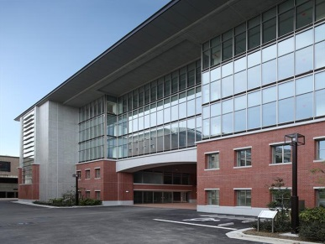**International Science Innovation Building** – Over 40 companies including Panasonic, Arkray, Bayer etc., international/ domestic universities, branch offices of Kyoto Prefecture and the City of Kyoto congregate in the building. Joint research projects such as “Wireless Energy Transfer,” “Preventive Halethcare, “Advanced Healthcare” and more are being conducted at the moment.



**Center for iPS Cell Research and Application** – Basic research and applied research on iPS cells are conducted. Not only iPS cell research, but also the management of intellectual property, handling regulatory authorities, and promotion activities are some of their operations. In reaction to Dr. Yamanaka (the director of the CiRA)’s win for Nobel Prize in Physiology or Medicine in 2012, MEXT has decided to subsidize CiRA for the coming ten years.

12:00- Transfer to ICC by taxi

### 12:30-13:20 Lunch at ICC

*Venue: Room ? at ICC*

### 13:20-14:30 Plenary Session 202: Global Health

*Venue: Main Hall at ICC*

***Speakers:***

* [Chair] Dr. Henry A. McKinnell, Chairman, Moody’s Corporation, US
* Prof. Shinya Yamanaka, Director, Center for iPS Cell Research and Application (CiRA), Kyoto University; Nobel Laureate in Physiology or Medicine in 2012, JP
* Dr. Elias A. Zerhouni, U.S. Science Envoy; President, Global R&D, Sanofi, US
* Mr. Christophe Weber, President & CEO, Takeda Pharmaceutical, FR
* Dr. Leroy Hood, President, Institute for Systems Biology, US
* Dr. Jörg Reinhardt, Chairman, Novartis A.G. CH

### 14:30-15:00 Bilateral Meeting with Professor Jean-Pierre Bourguignon, President, European Research Council (ERC), European Commission

*Venue: Room 677 at ICC*

*Dr. Bouguignon’s cell: +32 460 75 87 69

|  |
| --- |
| **Background Information** |
| **Prof. Jean-Pierre BourguignonDr. Jean-Pierre Bourguignon, President of the European Research Council**  Dr. Bourguignon is the former Director of the Institut des Hautes Études Scientifiques (from 1994 to 2013). He serves on the scientific council of several institutions of international standing.  He holds an engineering degree from the École Polytechnique and a PhD in mathematical sciences from the University Paris VII. He is a member of the Academia Europaea and a foreign member of the Royal Spanish Academy of Sciences. In 1997, he received the Prix du Rayonnement Français in Mathematical Sciences and Physics and in 2005 was elected honorary member of the London Mathematical Society. He holds honorary degrees from Keio University, Japan (2008) and from Nankai University, China (2011). From 2007 to 2011, he was President of the Ethics Committee of Centre National de la Recherche Scientifique – CNRS. |

### 15:00-16:20 STS Seminar “Responsible Public Dialog in Science and Technology”

(Seminar starts at 14:40)

*Venue: Room ? at ICC*

***Speakers:***

* [Chair] Dr. Marcia McNutt, Editor-in-Chief, Science, AAAS, US
* Prof. Astrid Söderbergh Widding, Vice-Chancellor, Stockholm University, SE
* Sir Richard J. Roberts, Chief Scientific Officer, New England Biolabs; Nobel Laureate for Physiology or Medicine 1993, GB
* Mr. Youngsuk Chi, Chairman, Elsevier Inc., US
* Mr. Michael Matlosz, President and Chief Executive Officer, French National Research Agency (ANR), US
* Dr. Fiorenzo Marco Galli, Director-General, National Museum of Science and Technology Leonardo da Vinci, IT
* Prof. Dr. Fidel Castro Diaz-Balart, Scientific Advisor, State Council of Cuba, CU

### 16:20-16:50 Coffee Break

### 16:50-17:05 Coffee with Elsevier, Inc.

*Venue: Coffee break area on 1fl. at ICC*

***Participants:***

* Mr. Youngsuk Chi, Chairman, Elsevier Inc., US
* Michiel Kolman,  Senior Vice President Global Academic Relations (President Elect International Publisher Association, 2017 -)
* Anders Karlsson, Vice President, Strategic Alliances, Global Academic Relations

|  |
| --- |
| **Background Information** |
| YS Chi**Mr. Youngsuk ‘YS’ Chi, Chairman of Elsevier and Director of Corporate Affairs and Asia Strategy for RELX Group**  As the Director of Corporate Affairs and Asia Strategy for RELX Group, Mr. Chi is responsible for government affairs, corporate communications, and corporate responsibility for Elsevier’s parent company. As non-executive Chairman of Elsevier, he works directly with governments, Elsevier customers and in industry associations worldwide. Mr. Chi recently completed 4 years of service as the President of the International Publishers Association, a global organization that represents the interests of more than 50 publishing industry association members from countries around the world. Previous positions also include Co-founder of Lightning Source, the first ever print-on-demand distributor and e-book services provider, several senior executive positions at Ingram Book Group’s parent company and President and Chief Operating Officer of Random House. Mr. Chi has earned widespread respect for his ability to work across cultures. He holds a Bachelor's degree from Princeton University and an MBA from Columbia University. |

### http://2.bp.blogspot.com/-sZ0ugJLWkI0/Ur1GPaI4j_I/AAAAAAAAcaE/t08ufIizPm8/s800/present_box.png17:15-17:45 Bilateral meeting with the president of Japan Science & Technology Agency (JST)

*Venue: Room 673 at ICC*

*contact person: Mr. Hasegawa @03-6261-0445

|  |
| --- |
| **Background Information** |
| **JST** – the Japan Science & Technology Agency promotes science and technology “top-down” to create new values that lead to the future, in order to advance the national welfare and prosperity. It is one of two major funding agencies supported by the Ministry of Education, Culture, Sports, Science and Technology (MEXT). The other major funding agency is Japan Society for the Promotion of Science (JSPS).  JST had a collaboration agreement with VINNOVA and SSF and jointly supported research in the area of Multi-disciplinary Bio. JST also has often collaborated with the Office of Science and Innovation, Embassy of Sweden for various events.  <http://www.jst.go.jp/EN/index.html>  **Dr. Michinari Hamaguchi, President of JST**  President of JST since October 1st, 2015. Previous positions include president of Nagoya University, Dean of Nagoya University School of Medicine/Graduate School of Medicine, Director of the Supporting Center for Medical Research and Education as well as Professor at the Division of Cancer Biology at Nagoya University Graduate School of Medicine. His areas of expertise in research include Cancer Biology, Cancer Biochemistry and Cellular Biology. |

18:00-18:30 Transport to Nijo Castle (Nijo-jo), UNESCO World Heritage Site

Transportation: shuttle bus provided from ICC to the castle

### 18:30-20:30 Dinner arranged by STS Forum

*Venue: Nijo Castle*

20:30 Transport to the hotel by shuttle bus provided by STS Forum

## Tuesday, October 6

08:30 Meet at Hotel Gravia Kyoto, lobby

Pick up by Niklas Kviselius

Transport to Tokyo by Shinkansen (bullet train)

9:26 (Kyoto) -11:43 (Tokyo)

11:50 Meet Shiori at Marunouchi North Exit at Tokyo Station

### 12:00-13:00 Lunch

*Venue: Washoku En – See Appendix E*

***Participants:***

* Dr. Dan Öberg, Programs in English at Komaba (PEAK), University of Tokyo

|  |
| --- |
| **Background Information** |
| **PEAK** – Programs in English at Komaba – The University of Tokyo has started the undergraduate degree programs to be taught entirely in English since October 2012. Two courses, the International Program on Japan in East Asia and the International Program on Environmental Sciences are available.  **http://www.fhs.se/scaled/externwebben/om-fhs/kontakta%20oss/medarbetare/%C3%B6/dan-oberg/dsc_0217portr%C3%A4tt-width120.jpgDr. Dan Öberg, Senior Lecturer at the Swedish Defence University**  Currently visiting lecturer at Tokyo University. He has been granted the Teaching Sabbatical Scholarship from STINT to teach at Tokyo University during the fall of 2015 and teaches under PEAK program. His focus areas of research and education are Critical perspectives on war and warfare, The Japanese navy in the Pacific War, Information operations and military targeting and Air power theory. |

Transport to AMED at Otemachi– See Appendix F

### http://2.bp.blogspot.com/-sZ0ugJLWkI0/Ur1GPaI4j_I/AAAAAAAAcaE/t08ufIizPm8/s800/present_box.png14:45-15:45 Meeting with the president of the Japan Agency for Medical Research and Development (AMED)

*Venue: AMED*

Meet the head of International Affairs Division at the lobby on 1F

Contact: 03-6870-2216

|  |
| --- |
| **Background Information** |
| **AMED** – the Japan Agency for Medical Research and Development is an organization that plays a central role in medical research development and its environmental management. It is an independent administrative agency and is established in April 2015 under Cabinet Office. The agency consolidates the funding that used to be managed by multiple government offices and allocates the research funding into universities and research institutions based on the strategy that the central government lays down.  **Dr. Makoto Suematsu, President, AMED**  Born in 1957. Before taking on his current position at AMED, Dr. Suematsu was the Dean of Keio University’s School of Medicine. He holds a Ph.D. in the field of gastroenterology and microvascular physiology from the same school. After completing his postgraduate studies, Dr. Suematsu joined the Institute for Biomedical Engineering, University of California San Diego as a bioengineer. He was later appointed professor and chair at the Department of Biochemistry and Integrative Medical Biology, Keio University School of Medicine, the leader of the National Leading Project for Biosimulation by the Ministry of Education, Sciences and Technology and thereafter the leader of the Global Center of Excellence for Life Sciences, Human Metabolomic Systems Biology at Keio University. |

Transport to the Hotel Okura and check in

18:00 Meet at the lobby of Hotel Okura

Pick up by Niklas Kviselius

Walk to the Embassy of Sweden

### 18:30-20:30 Dinner hosted by Ambassador Magnus Robach

*Venue: Ambassador’s Residence*

***Program:***

18:00 Guests arrive

18:30 The event starts (Dr. Hashimoto moderates)

18:35ca The Ambassador’s speech

18:40ca Minister Knutsson’s speech

18:45ca Dinner starts

20:45 Dinner ends

***Participants:***

* H.E.Mr. Magnus Robach, Ambassador
* H.E.Ms. Helene Hellmark-Knutsson, Minister of Higher Education and Research
* Ms. Marija Miliojevic, Head of Section, Division of Research Policy
* Mr. Klas-Herman Lundgren, Political Advisor to the Minister
* Ms. Maria Soläng, Press Secretary to the Minister
* Dr. Yuichiro Anzai, President, JSPS
* Dr. Setsuko Hashimoto, President & CEO, CellSeed
* Dr. Kyosuke Nagata, President, Tsukuba University
* Dr. Keisuke Goda, Program Manager, ImPACT; Professor, University of Tokyo
* Mr. Takeshi Fujiwara, Country Manager, Mölnlycke Health Care KK
* Dr. Andreas Göthenberg, Executive Director, STINT
* Dr. Niklas Kviselius, Science and Innovation Counsellor, Head of Office of Science and Innovation, Embassy of Sweden
* Ms. Victoria Forsberg Bellass, Minister Counsellor, Embassy of Sweden

|  |
| --- |
| **Background Information** |
| **Ambassador of Sweden in Japan, Magnus Robach**  Ambassador Robach has held the role of Ambassador of Sweden in Japan since 2014. Before that served as ambassador in Brazil (2011-2014) and in Belgium (2007-2011). He has also been appointed Director-General and Head of the EU Coordination Secretariat at the Swedish Prime Minister’s Office and Minister at the Swedish Embassy in Paris. Furthermore he has held various positions at the Swedish Ministry of Foreign Affairs, including Head of EU Department and other posts with regard to arms control, international trade and administration. Ambassador Robach has an educational background in Journalism, Russian, Political Science, History and Philosophy.  **Dr. Yuichiro Anzai, President of Japan Society for the Promotion of Science (JSPS)**  Dr. Anzai also serves as a member of the Council for Science and Technology and Chairperson of the Japanese National Commission for UNESCO. From 2001 to 2009, Dr. Anzai was President of Keio University. Prior to that, he was Dean of the School of Science Technology (1993 to 2001) and Professor of Computer Science (starting in 1988) at Keio. He also served as President of APRU, and Chairperson of the Central Council for Education.  **JSPS – Japan Society for the Promotion of Science**  The Japan Society for the Promotion of Science (JSPS) is Japan’s leading funding agency and is largely funded through annual subsidies from the Japanese Ministry of Education, Culture, Sports, Science and Technology (MEXT). Established in 1932, JSPS promotes the advancement of academic research in all disciplines from social sciences and humanities to natural sciences and engineering. The main functions of JSPS are to fund research initiatives, foster the next generation of scientists, advancing international collaborations and promote university reform. JSPS administers a number of bilateral and multilateral programs for scientific cooperation and exchange under memorandums of understanding concluded with its various counterpart foreign academic institutions around the world.  **Dr. Kyosuke Nagata,** **President, University of Tsukuba**  Dr. Nagata is a scientist and specializes in molecular biology. He received a Doctorate degree in pharmaceutical sciences from the University of Tokyo in 1981.  **University of Tsukuba**  University of Tsukuba is one of the oldest national universities in Japan and it’s located in Tsukuba City in Ibaraki Prefecture. It is famous for research in physics, economics, physical education and social science. The university was chosen as one of the institutions of higher education as part of MEXT’s 13 “Global 30” universities. It has active in industry-university collaboration activities, and the number of ventures originated in University of Tsukuba is 104 cases in total.  **Dr. Keisuke Goda**, **Program Manager, ImPACT Program, Cabinet Office, Government of Japan; Professor of Physical Chemistry, University of Tokyo; Adjunct Faculty Member of Electrical Engineering, University of California, Los Angeles**  Dr. Goda is currently a Professor of Physical Chemistry in the Department of Chemistry at University of Tokyo. His research focuses on the development of innovative technologies such as novel methods, devices, and instruments for a diverse range of scientific, industrial, and biomedical applications. He is a program manager of ImPACT and his project is “Turning Serendipity into Planned Happenstance”.  **ImPACT**  ImPACT - Impulsing Paradigm Change through Disruptive Technologies Program was established by the Cabinet Office to promote challenging research development (high risk, high impact) aiming at creating science and technology innovation that can bring major change in industry and society if realized.  **Dr. Setsuko Hashimoto, President and CEO of CellSeed Inc.**  Dr. Hashimoto has over 30 years commercial experience in bio-industry with proven expertise in creating bridges between Japanese and overseas organizations. Dr. Hashimoto is well networked globally to academia, government and industry. With international research experience in life sciences, Dr. Hashimoto was implemental in establishing new business of Biacore (Swedish biotech company, now part of GE Healthcare) where she created and significantly grew the market in Japan for the company. CellSeed Inc. established a subsidiary in Sweden to conduct clinical trial in Sweden.  **Mr. Takeshi Fujiwara** , **Country Manager, Mölnlycke Health Care KK**  Mr. Fujiwara is furthermore the Vice Chairman of SCCJ - The Swedish Chamber of Commerce and Industry in Japan. Previous positions include Design Engineer at Toshiba Automation, Manager at the Engineering Department of Fuji Film in Germany and President of Gambro. He has also served as board member of the Medical Technology Association of Japan as well as of the Japan Sweden Society. Mr. Fujiwara has an educational background in Industrial Engineering.  **Dr. Andreas Göthenberg, Executive Director of STINT**  Dr. Göthenberg was appointed Executive Director of STINT as of September 1, 2009. He received his M.Sc. and Ph.D. degrees from KTH Royal Institute of Technology, Stockholm, Sweden, in 1996 and 2003, respectively. From 2006 until 2009 he was a Science and Technology Attaché at the Embassy of Sweden in Tokyo, Japan. Previous to that he was working as a Center Manager and Senior Researcher in China, setting up joint research and education centers for KTH Royal Institute of Technology at Zhejiang University and Fudan University. He has been a Post Doctoral Research Fellow at Tokyo Institute of Technology and is currently an Adjunct Associate Professor at the Chinese University of Hong Kong. He has also been with Texas Instruments Inc., Dallas, Texas, U.S.A., and is a Senior Member of the Institute of Electrical and Electronics Engineers, Inc.(IEEE).  **Dr. Niklas Z. Kviselius, Counselor and Head of the Office of Science and Innovation at the Embassy of Sweden in Japan**  Dr. Kviselius has worked at the Office of Science and Innovation and the Swedish Agency for Growth Policy Analysis in Tokyo, covering Japan and South Korea, since 2009. Ahead of this he conducted research in the field of information technology and communication at Waseda University in Tokyo as well as Uppsala University and Stockholm School of Economics in Sweden. He holds a Ph.D. from Stockholm School of Economics and Stockholm University School of Business, including studies at Waseda University Graduate School of Global Information and Telecommunication Studies.  **Ms. Victoria Forslund Bellass, Minister Counsellor of Embassy of Sweden, Tokyo**  Ms. Forslund Bellass studied Political Sciences and Economics at graduate school at University of Stockholm. Apart from serving at the Headquarter of Swedish Ministry for Foreign Affairs, she worked at Swedish Embassies in Zimbabwe and Estonia, before assuming her present position in 2014. |

## Wednesday, October 7

07:40 Meet at Hotel Okura, Main Bldg, lobby

07:50 Airport Limousine to Narita Airport leaving Hotel Okura (Marija,

Klas-Herman, Maria)

08:00 Pick-up by Embassy car (Minister and the Ambassador)

11:00 Departure from Terminal 2 of Narita International Airport on

Finnair (AY74)

Notes:

Appendices: References

## Appendix A: Meeting with Niklas!

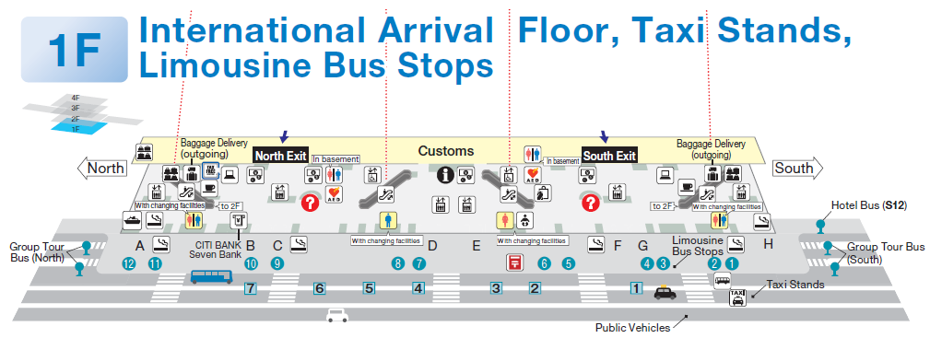**Niklas will be waiting right outside the North Exit.**

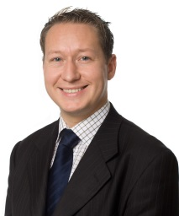

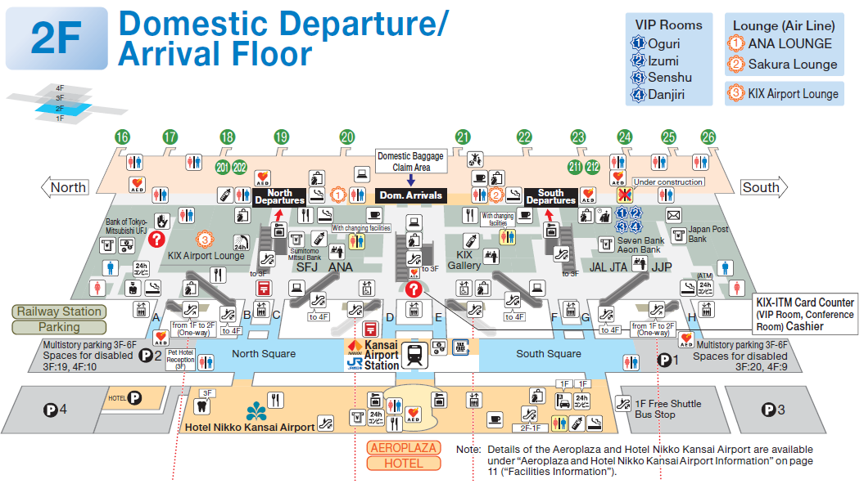**Go upstairs for the Kansai Airport Station to get on Express Haruka. The gate is on the 2nd floor.**

Kansai Airport Station looks like this:

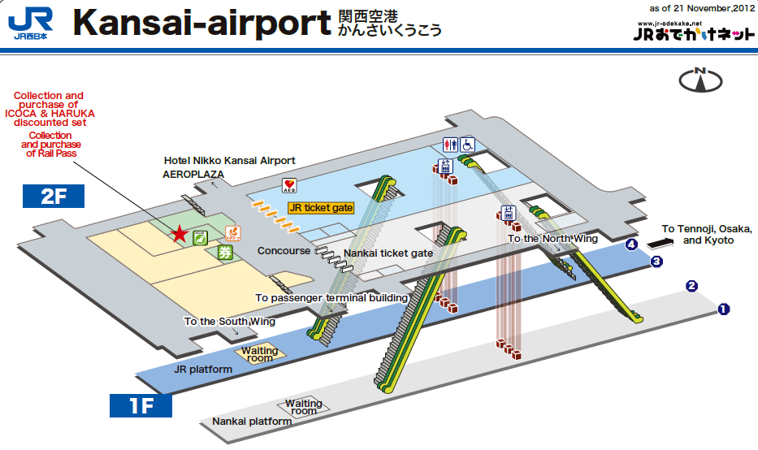

After exiting from the Central Gate of the Kyoto Station, take the escalator on your right to the Lobby on the 2nd floor of the hotel (see below).

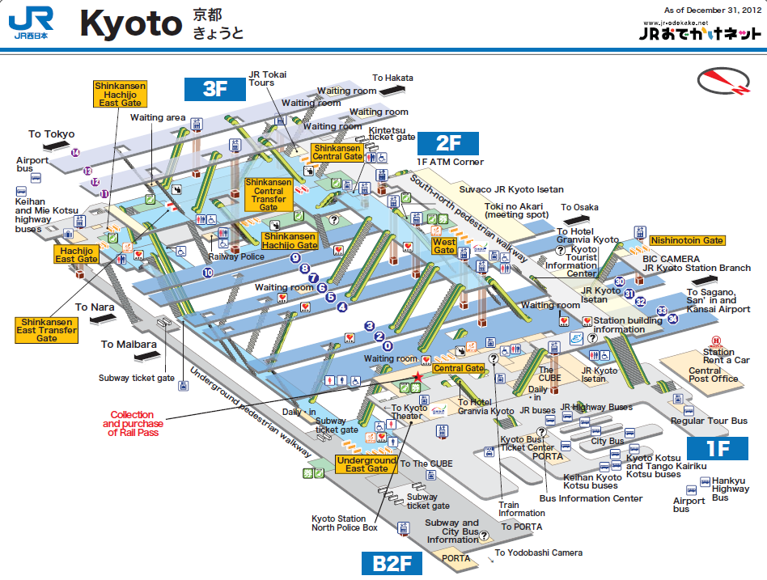

## http://www.ihtc-15.org/images/venue/kyoto_access_map.jpgAppendix B: Kyoto City Map & the hotel

ICC (京都国際会館): 京都市左京区岩倉大鷺町422

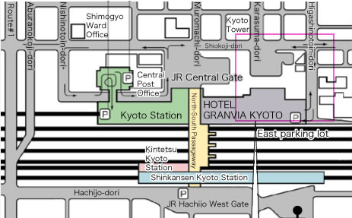

Hotel Granvia Kyoto

〒600-8216 京都市下京区烏丸通塩小路下ル JR京都駅中央口

TEL：075-344-8888

## Appendix C: Japanese restaurant “Suiren”

〒605-0801

京都市東山区宮川筋２－２５３

2-253 Miyagawasuji, Higashiyama-ku, Kyoto-shi

Phone: 075-748-1988

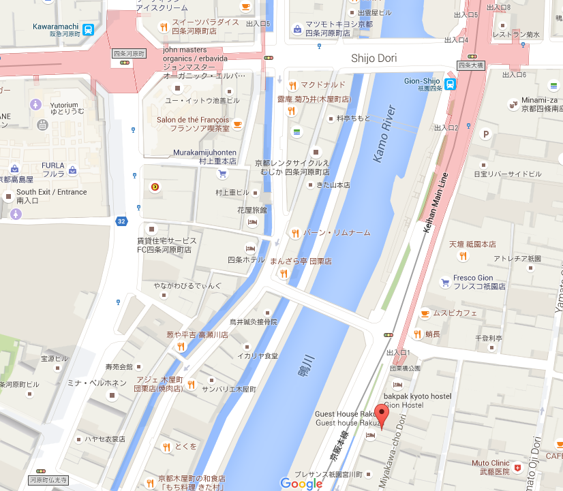

## Appendix D: Kyoto University

〒606-8501 京都市左京区吉田本町

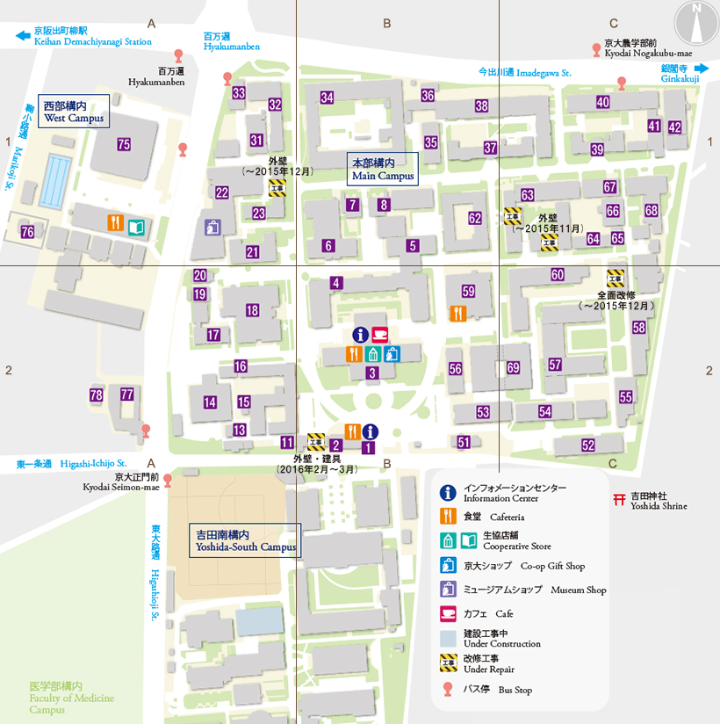

1 – Main Gate/Information Center

69 – International Science Innovation Building

## Appendix E: Washoku EN Marunouchi

〒100-0005 千代田区丸の内1-6-4 504丸の内オアゾ5F  
TEL：03-5223-9896 （Reserved 7 seats under Shiori Schules）

Washoku EN offers diners authentic and original Japanese dishes made with carefully selected seasonal ingredients.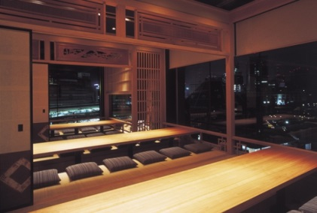 Depending on the season, EN offers special seasonal menus, allowing diners a chance to experience new and exciting dishes with every visit. The Marunouchi branch has a look that is a mix of Japanese tea ceremony garden with European influences, giving the restaurant an elegant and modern feel.

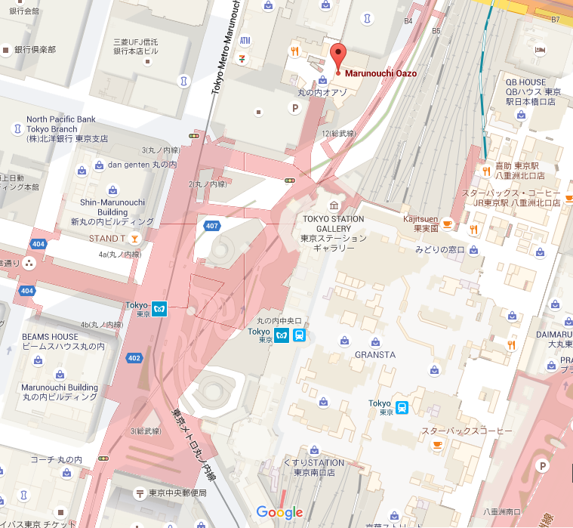

## Appendix F: AMED (Japan Agency for Medical Research and Development)

〒100-0004   
東京都千代田区大手町1－7－1 読売新聞ビル20階（総合受付）  
Tel : 03-6870-2200

AMED

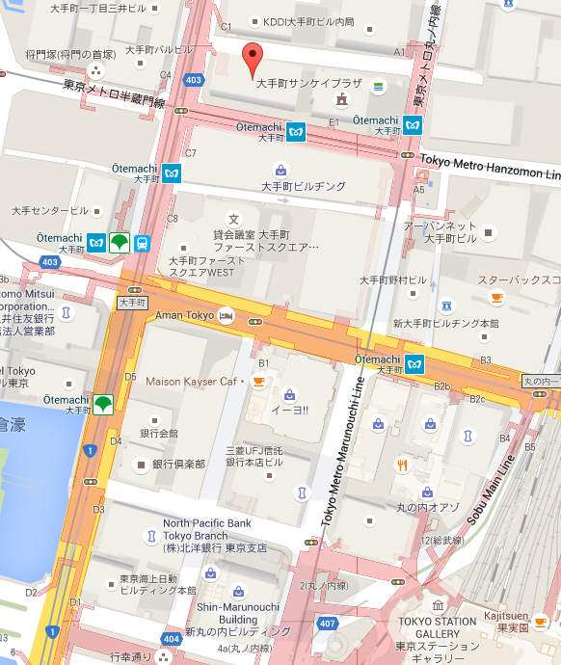

Tokyo Station

## Appendix G: Contact information

**Growth Analysis**

Niklas Z Kviselius, +81-80-4189-1276

Shiori Schules, +81-80-1111-3954

Growth Analysis Tokyo Office, +81-3-5562-5030

**Embassy of Sweden**

Embassy of Sweden Tokyo, +81-5562-5050 (9-17:30)

**Delegation to Japan**

H.E.Ms. Helene Hellmark Knutsson, +46

Ms. Marija Milivojevic, +46 70 867 92 96

Mr. Klas-Herman Lundgren, +46

Ms. Maria Soläng, +46 72 206 19 47